ALAN CARTER STUDIO
5332 RIVERVIEW DR., LISLE, IL 60532 630-971-0690
apcarter@sbcglobal.net www.alancarterstudio.com

DRILLING FIXTURE FOR LATHE

This fixture is designed to drill holes in a vessel mounted on the lathe so that the holes are in line with and perpendicular to the center line of the lathe. This ensures that the mounting pins connecting the vessel with its supporting legs will be properly spaced and the vessel will hang correctly. The fixture locks in place and, using the indexing feature, evenly spaced holes can be drilled around the circumference of the vessel. Using spacer(s) allows multiple parallel holes to be drilled, also evenly spaced. The spacer(s) are then used with a stop block on the drill press to drill holes in the legs which will also be properly spaced.

The drilling fixture can travel up to 10” from the center of the lathe bed. The platform that supports the drilling sled can be adjusted up or down and has a 12” sideways travel. Small clamps hold the sled in place while the holes are being drilled. Removing the right angle portion of the base unit allows the fixture to swivel so holes can be drilled at an angle.

The majority of the parts are made of ½” and 5/8” Baltic birch plywood and solid maple.

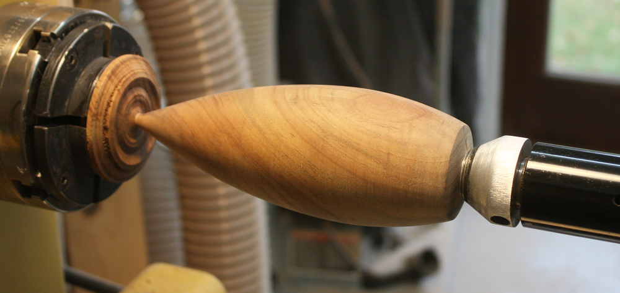
Vessel mostly turned and hollowed, ready to have holes drilled

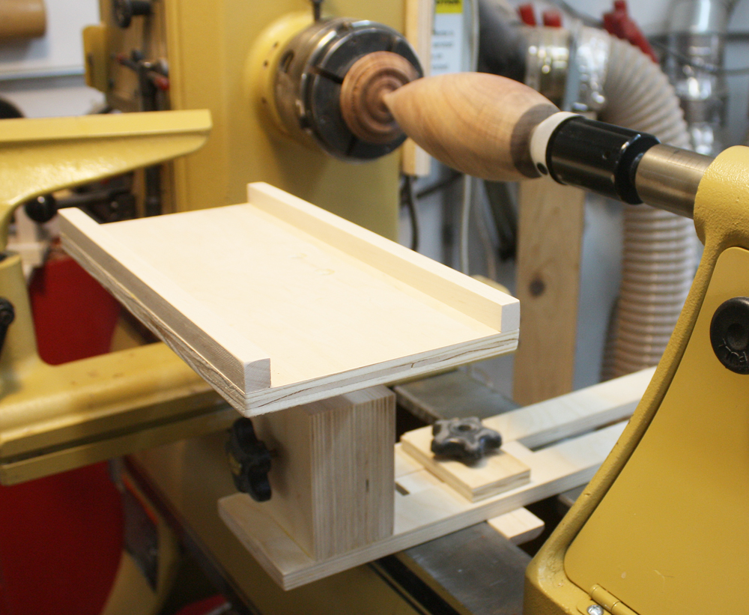
Platform mounted on lathe. Note that it can slide in and out depending on the diameter of the turning.

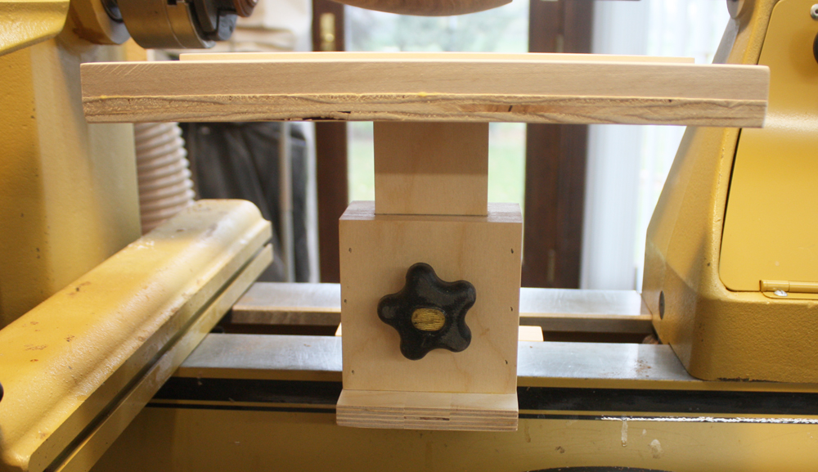
End view of platform showing locking knob for the support column. The column can travel vertically several inches to accommodate different sizes of lathes.

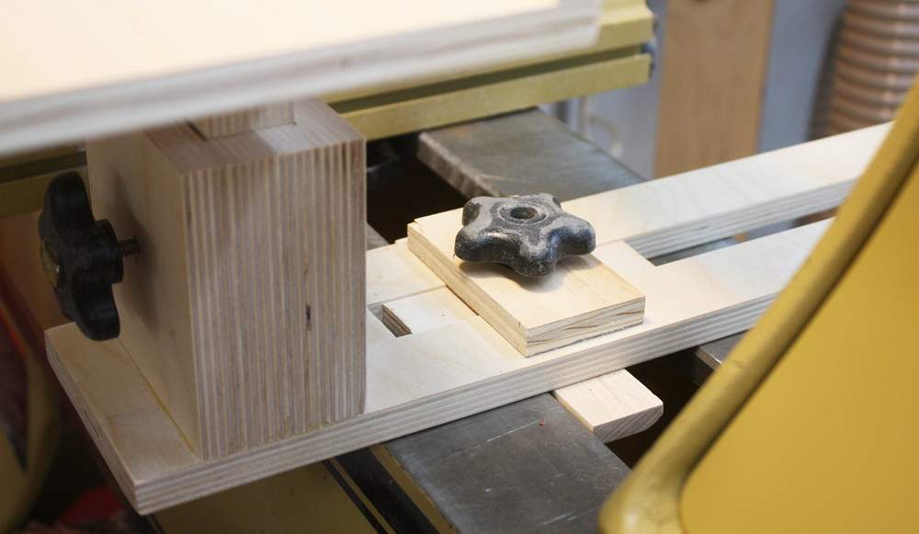
Closeup of locking mechanism. A cleat underneath the lathe bed clamps the platform securely. The sliding right angle bracket ensures the platform will be perpendicular to the lathe bed.

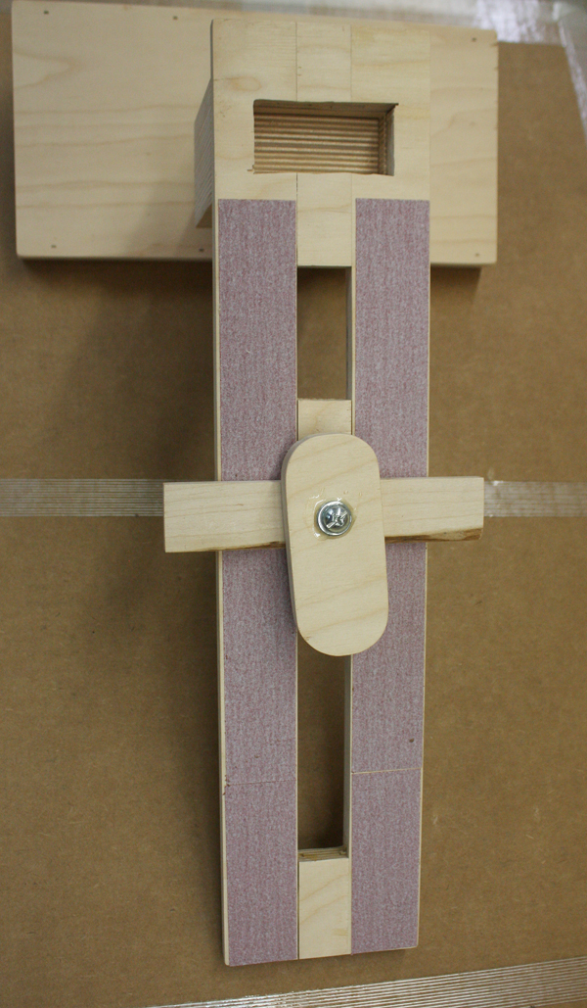
Underneath side of platform showing locking cleat. The strips of sandpaper hold the platform firmly in place.

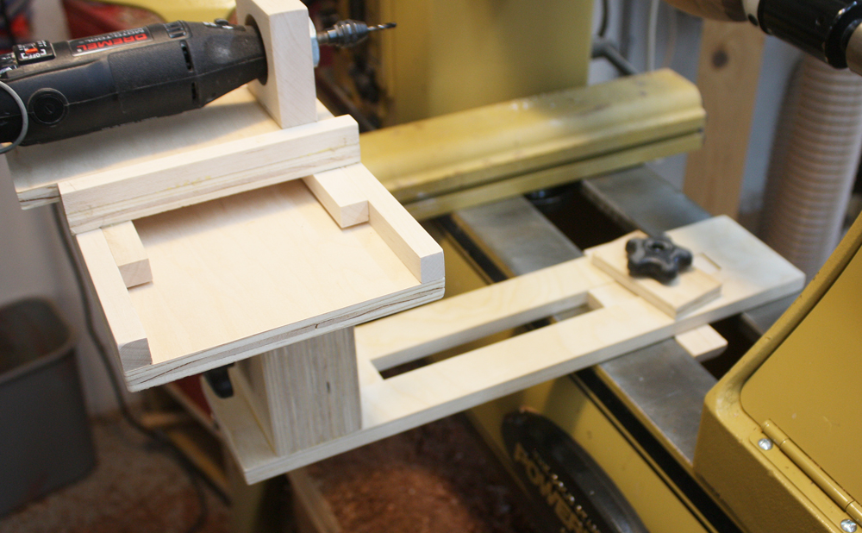
This view shows the platform moved further away to accommodate a larger vessel.

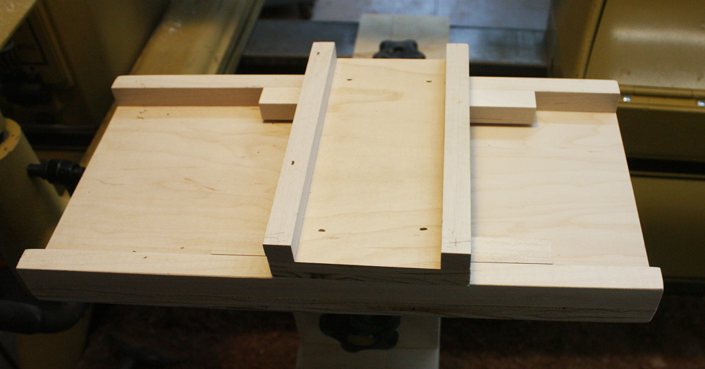
The sled that holds the Dremel tool. The sled slides sideways for drilling multiple parallel holes. The platform is 12” wide and the sled will travel around 8”.

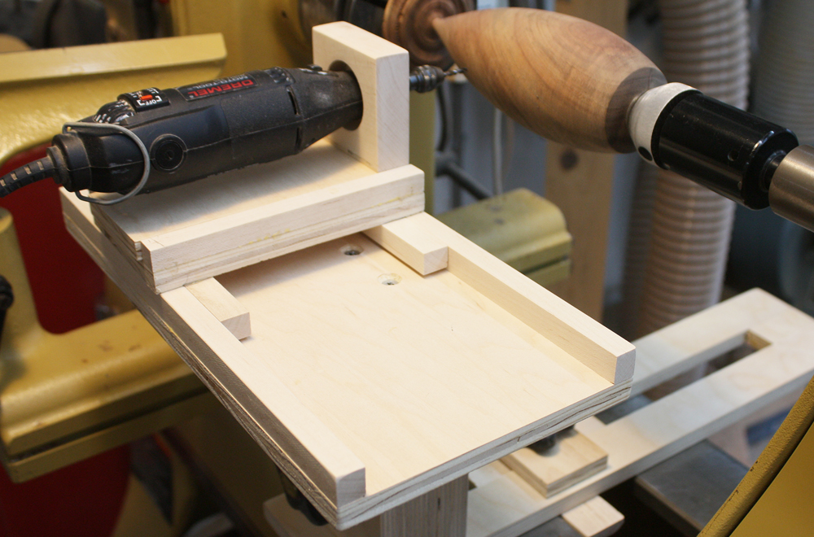
The sled with the Dremel in its holder. The holder slides forward to drill the holes in the vessel.

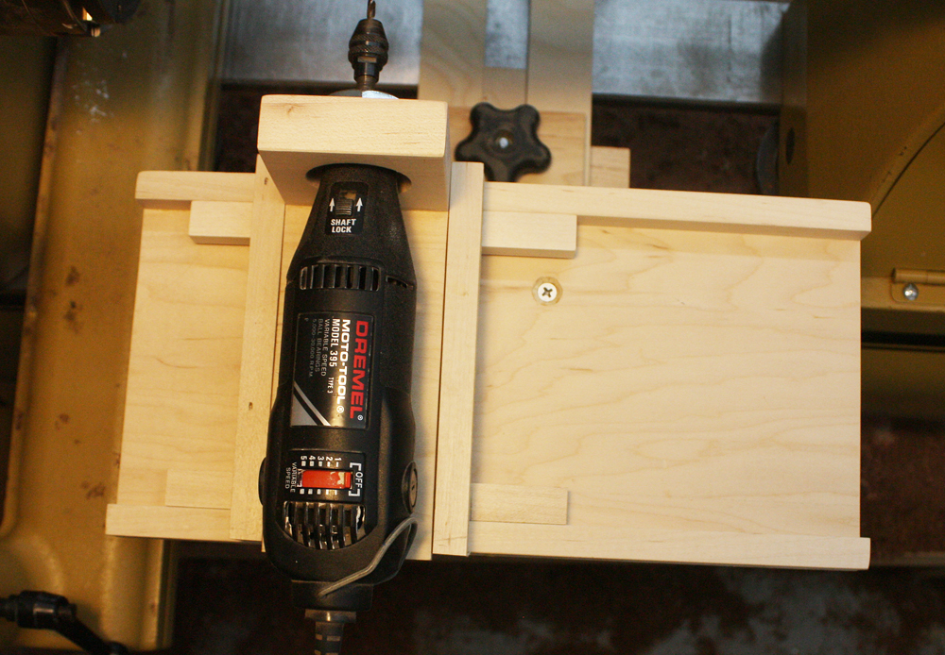
Top view of sled and Dremel in its holder The sled can be clamped in place if just one hole is to be drilled for each leg.

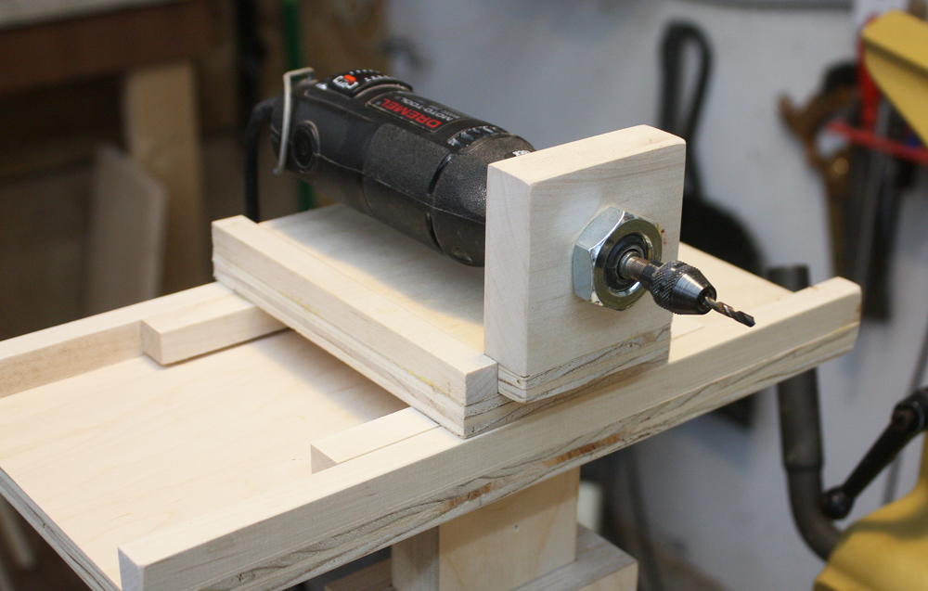
End view of Dremel in its holder

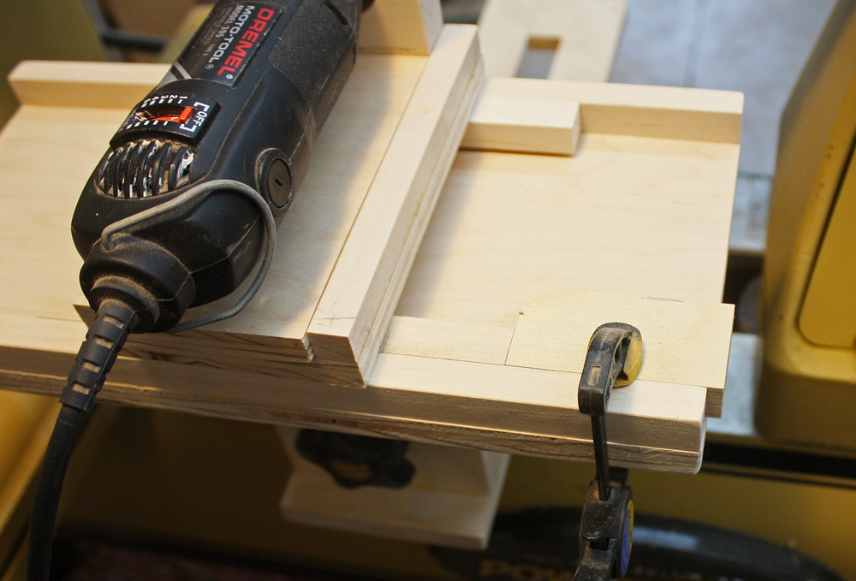
If 2 or more holes are need for each leg, the stop block is clamped to the platform and one or more spacers will be used to drill the holes the proper distance apart..

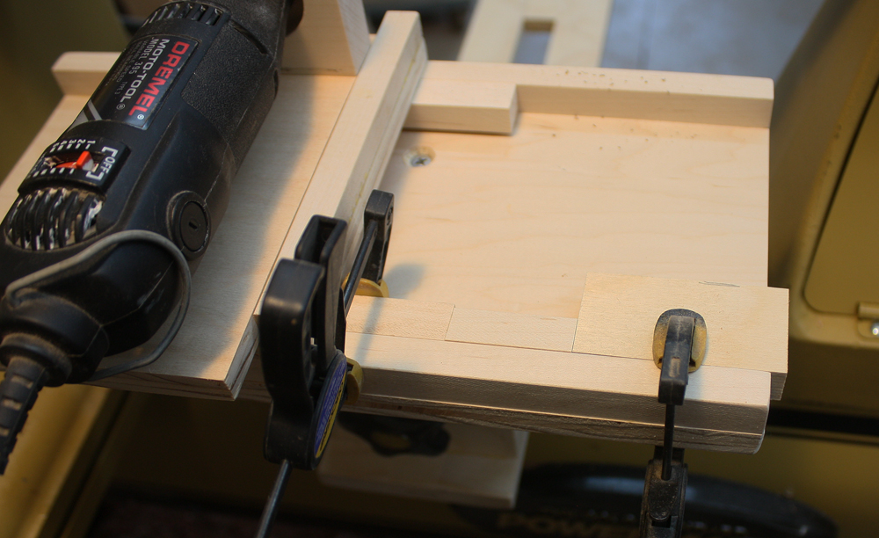
The spacer is used to allow parallel holes to be drilled accurately. The sled has been clamped to the platform so all the holes will line up properly.

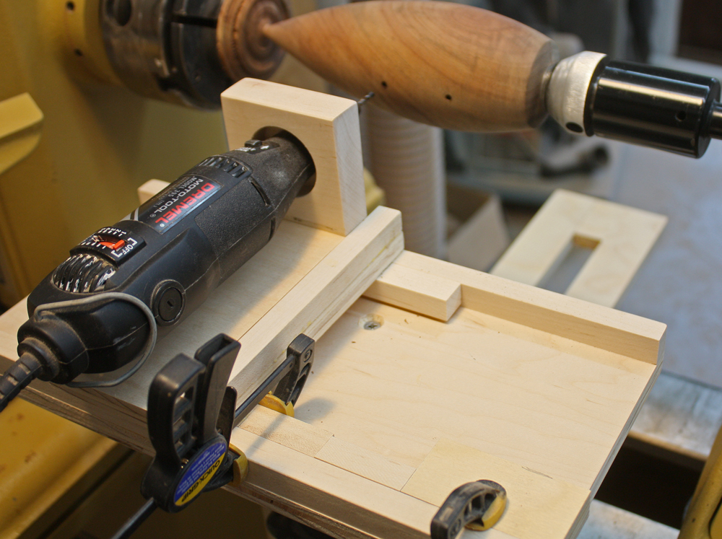
In this instance 2 mounting holes are drilled on each side of the vessel. Using the indexing feature on the lathe, the vessel has been locked in place. One hole is drilled and the spacer is inserted to drill the other hole. The vessel will then be rotated 180 degrees and the process repeated.
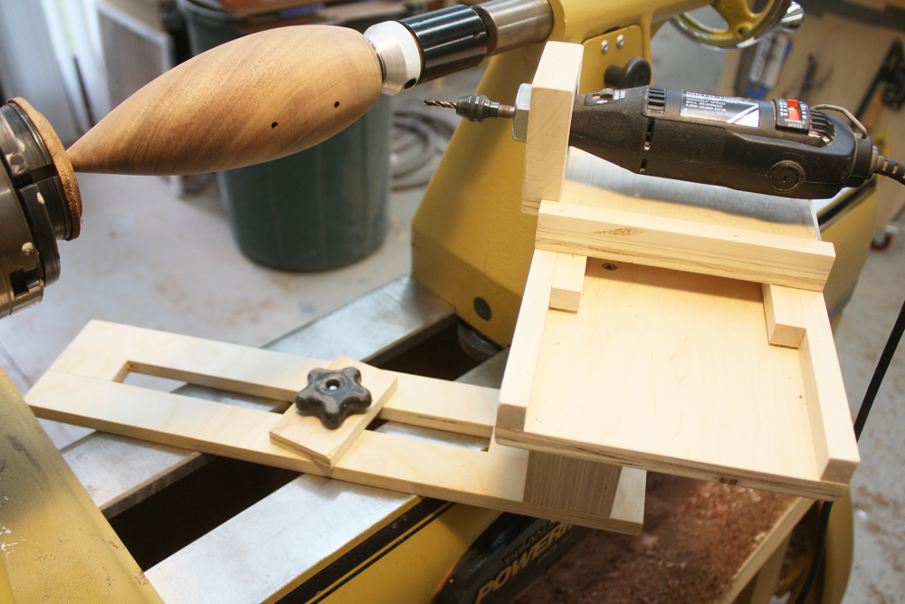
This view shows the platform without its right angle bracket so the fixture can be clamped at an angle.

EXAMPLES OF PIECES MADE USING THIS FIXTURE



