ALAN CARTER STUDIO
5332 RIVERVIEW DR., LISLE, IL 60532 630-971-0690
apcarter@sbcglobal.net www.alancarterstudio.com

TURNING SMALL GOBLETS

As a follow up to my thin stem article, here’s a how-to on turning the small goblets and vessels that sit atop the tall thin bases.

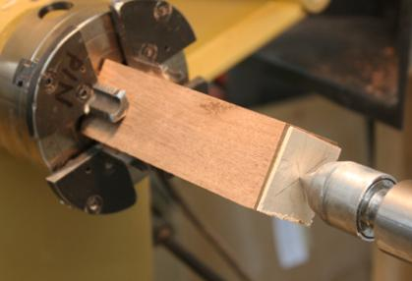

To begin with, I mount a blank in a 4 jaw chuck. The blank has been cut a couple of inches longer than the finished goblet to allow room to work on the base. I’ve also glued a thin square of maple to the end to make a contrasting rim. Note that I’ve marked the center of the blank so that the rim will be of a consistent thickness as it’s turned.

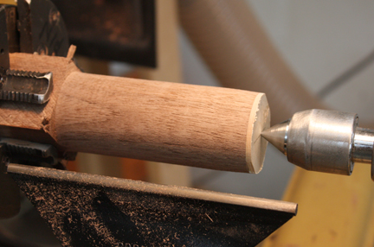

I’ve turned the blank to a rough cylinder.

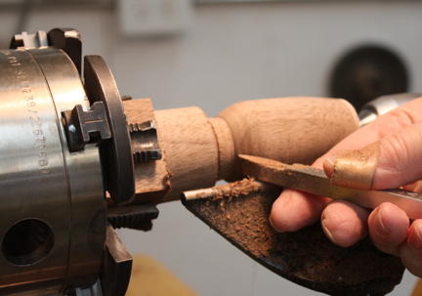

I’ve shaped the top of the goblet and am partially turning the bottom curve. Note that I didn’t remove much wood from the headstock end of the blank so I have a good support and enough mass when I work on the inside of the goblet.

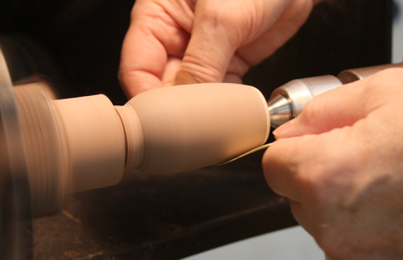

I’ve sanded the outside to about 400 grit. I still have quite a bit of wood supporting the bottom of the goblet.

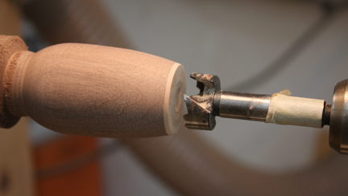

I’ve put a forstner bit in a Jacobs chuck in the tailstock to drill out a rough opening. The bit is a little smaller than the finished opening at the top of the goblet. Note the masking tape used as a depth gauge so I don’t drill too deep. Drill at the recommended speed and clear the shavings frequently so the wood doesn’t overheat or the drill bit bind up in the hole. Don’t drill too deep as the bit leaves a small hole due to the protruding point. This hole needs to be removed using the round finisher so the bottom of the goblet is smooth.

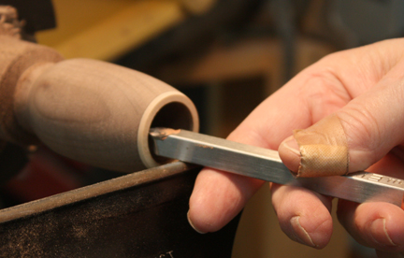

I’ve started hollowing the goblet using the finisher, working from the top down towards the base. I take small cuts being careful not to get catches or excess tear-out inside the goblet. I want the walls to be around 1/16” or less. I use a combination of calipers and my fingers to judge how thick the walls are. I also listen to the sound the cutter makes and use that as an additional aural guide.

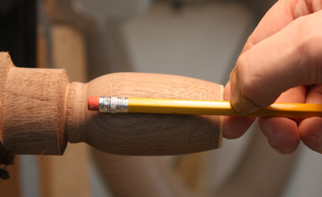

I use a pencil to determine how deep the hole is. I want a little mass left in the bottom so I have enough wood available to round over the outside without cutting through. Like that ever happens!

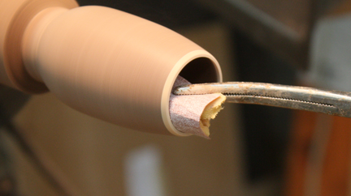

I’m sanding the inside of the goblet using sandpaper on a foam cushion, held in a clamping scissors, like a hemostat.

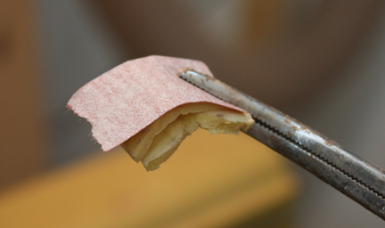

This shows the sandpaper and foam pads, which were cut from foam sanding pads. The hemostat is clamped at the right end, allowing the free left end to conform to the inside of the goblet. Minimal pressure is needed to sand the inside. I usually apply finish to the inside while it’s on the lathe, using the hemostat to hold a small pad dipped in finish. I normally use lacquer, but any finish may be applied this way. It’s easier than waiting until the goblet is off the lathe and having to get the finish evenly applied inside the small opening.

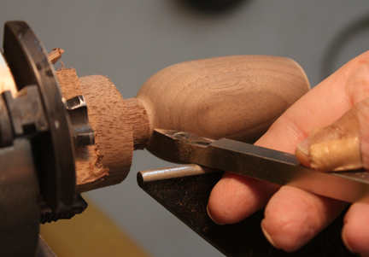

Here I’m taking the bottom to finished roundness a little at a time, keeping as much wood as possible at the headstock end.

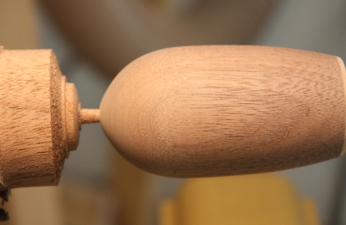

I’ve rounded the base and sanded it. Note that I’ve left a large enough gap so I can sand without getting my fingers caught. Also note I’ve left a small, 1/8” diameter tenon on the goblet. This fits into the 1/8” hole a drilled in the stem to glue the 2 parts together. The tenon is slightly undersized so it’ll fit in the hole easily.

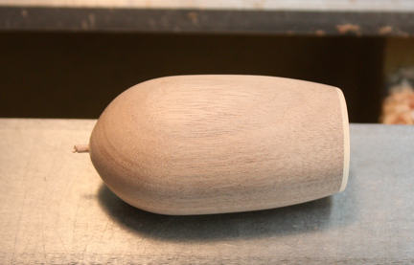

Here the goblet has been parted off and is ready for finish coats to be applied.

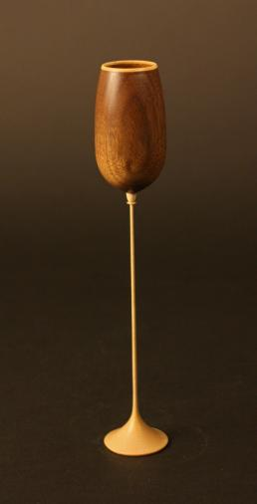

The goblet has been finished and glued to its thin stem base.
The design possibilities for goblets made this way are limited only by your imagination. These are a few of mine.

