THIN STEM TURNING
By Alan Carter

They say you can never be too rich or too thin. Personally, I’ve never been either, but I can show you how to make goblet stems as skinny as a fashion model on a diet. All it takes is some straight grained wood, a little patience, and a few sharp tools, including the Easy Wood roughers and finishers. The thin shaft demonstrated here is about 1/16” in diameter. It’s possible to make them even thinner, but you have to draw the line somewhere.

The first step is to mount a turning blank in a 4 jaw chuck. The size is up to you, but I usually start with a piece about 2” square by 7-8” or so long. Since the diameter of the stem’s base is determined by the cross section of the blank, give some thought about how big you want to make it, based on the size of the goblet or vessel supported by the stem. The tailstock end should have a dimple in the center to line up the live center.

Tighten everything down and turn a rough cylinder. Remove the live center and replace it with a Jacobs chuck with a small drill bit. At this point the cylinder is still pretty thick so it should run true without the tailstock support. I turn a small tenon on the end of the goblet head or vessel and drill a corresponding hole in the stem to attach the two. The tenon is usually 1/8” or 3/16” diameter and about 1/8” long, just enough to provide a foothold to glue the 2 pieces together and have them centered.

Once the hole is drilled, turn a small recess in the end to match the curve at the bottom of the goblet. This will allow the vessel to seat properly with no gap showing. You may have to adjust the depth and curve of the recess, so it’s best to make the goblet head or vessel before making the stem. It doesn’t have to be a perfect match. I use epoxy to glue the 2 parts together so any gaps are inconsequential.

Making the goblet head first also lets you establish the length of the stem so the 2 parts work together and the proportions will be correct.

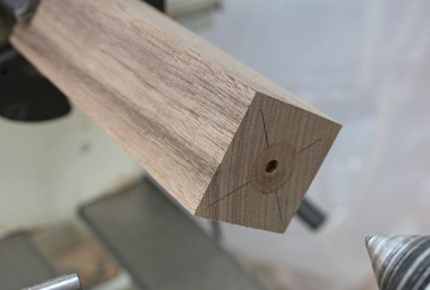
1. Blank mounted with hole and recess in end

Remount the live center and bring it up to the end of the blank. You want the center to snuggly engage the hole but don’t force it. You should be able to stop the live center from turning with just a little finger pressure. If you apply too much pressure, it can cause the wood to flex too much later on as the turning gets thinner. A little wax on the end of the center will help keep it from binding. The live center will stay in this position until the turning is completed. It’s this support that helps keep the stem from whipping around as it gets longer.

Turn the blank to a rough cylinder and taper the last 3 or 4 inches. Keep as much mass in the cylinder for as long as possible to avoid flexing as the diameter is reduced.

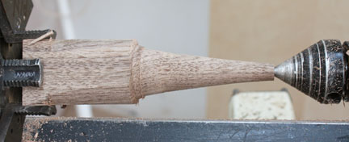
2. Blank turned with tapered cone at end.

Start shaping the end of the stem. You want a small cup to support the vessel. It needs to be longer than the hole you drilled so there’s enough support without it breaking off.

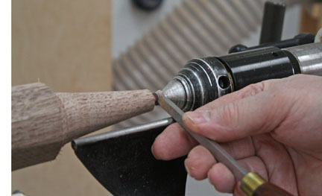
3. Shaping the end cup with a small skew.

Once the end cup is shaped, start removing material from the cone to create the stem.

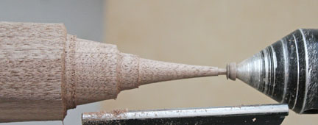
4. End with completed cup.

Work your way from right to left, taking shallow cuts and supporting the tool behind the wood if necessary. Don’t try to cut out too much wood at once, especially as you work down the stem. Take gentle sweeping cuts, making the completed portion of the stem consistent in diameter. Having you finger behind the wood helps control the depth of cut and keeps the cutting action smoother. I usually have the lathe running at about 2500 RPM at this point, so don’t use too much pressure unless you want to burn off your fingerprints. The small finisher is ideal for this because it will remove wood lightly and cleanly, avoiding catches and producing a very smooth finish.

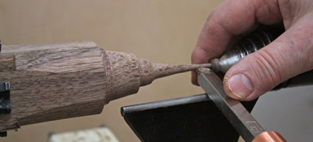
5. Working down the taper, keeping one finger behind the wood to support it.

As you progress down the stem, taper the blank every inch or so to reduce the diameter, but maintaining a substantial thickness upstream, so to speak, to prevent undo flexing. It may seem like it takes a while to get the results you want, but as the stem gets longer and thinner, the last thing you want to do is rush it and try to hog out too much wood. Hogging is best enjoyed in babyback form slowly cooked on a charcoal grill, not butchering a tender piece of maple with ham-handed aggressive cutting. (no more porcine metaphors- I promise.)

Sand as you go, working through the grits. Support the sandpaper with your fingers on opposite sides to prevent flexing. You want to finish sand each section before moving on. This is especially important as the length of the stem increases and there is less material to support anything. You can actually use the sandpaper to make the stem a bit thinner if you want, rather than using cutting tools. Just keep an eye on everything so it doesn’t get so thin it won’t support anything. (See last photo example!!)

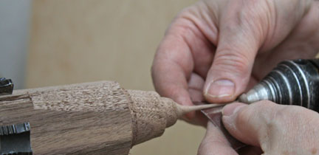
6. Sanding a completed section, supporting the stem to prevent flexing.

Continue shaping the stem, removing wood from the blank gradually. Take care not to overly flex the completed stem section. Continue down the stem towards the headstock, sanding as you go. Keep the stem as straight as you can so that it remains a very thin straight-sided cylinder. Use your fingers as well as your eye to avoid any dips or bumps in the stem.

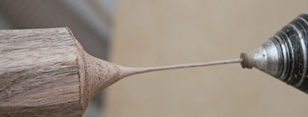
7. The stem, about half-way turned.

Continue until you get the stem as long as you want it or until your courage wanes and it’s time to call it quits. Remember to sand as you go and don’t use too much pressure on the completed stem section. Notice that the tailstock is engaged at all times.
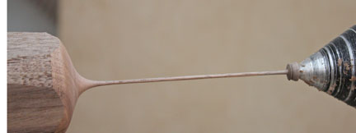
8. The stem turned and sanded at its final length.

I make a simple inverted cone shape for the base. I want the focus to be on the goblet or vessel mounted on top rather than on the stem itself. Of course, you can make the stem as elaborate as you wish.

Use a parting tool to partially cut through the completed stem below the base
Maintain enough solid wood connection at this point to facilitate final finishing.

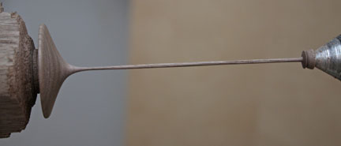
9. The completed stem prior to parting off.

At this point, give the stem a few coats of your favorite finish and let dry thoroughly. I find it’s easier to finish the stem while it’s on the lathe because of its delicate nature.
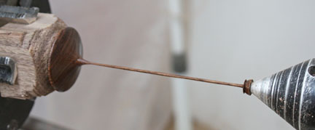
10. Stem with finish applied.

Once the finishing is complete, cut off the stem. Cut it so there is a concave surface on the underside sp the base will sit flat and not rock. Leave the tailstock engaged until you almost cut through the underside of the base. Back off the tailstock, cradle the stem loosely in you hand, and part it off. If you leave the tailstock engaged, the fragile stem may break when the base is parted off.

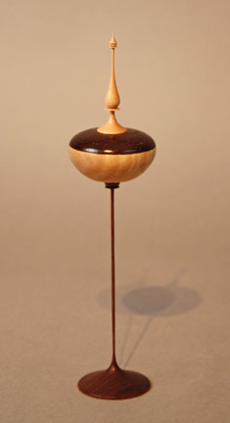
11. Completed stem with vessel mounted.
The stems can be either straight sided, as in the first 3 examples, or they can have additional elements, similar to the way finials are designed. Just don’t get too carried away, or your piece will droop under pressure, like the last photo. Nobody wants to see that.

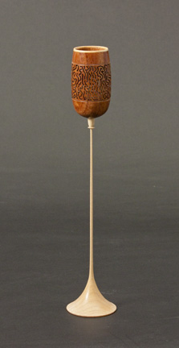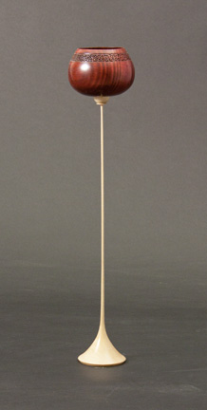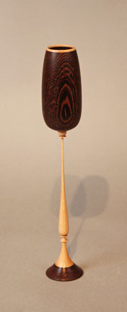

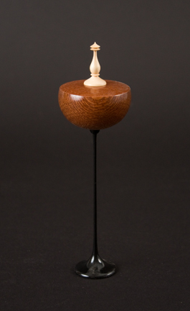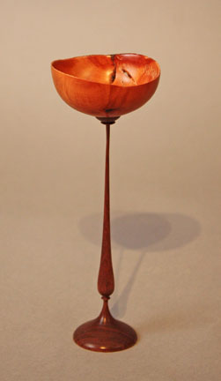

12. Examples of thin stem turnings.

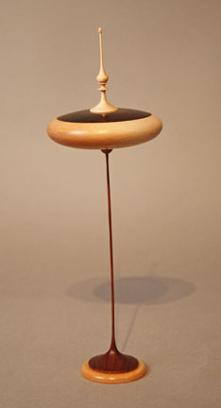
13. Example of thin stem turning gone amuck. I guess you can be too thin after all.

