OFFCENTER WINGED BOWL
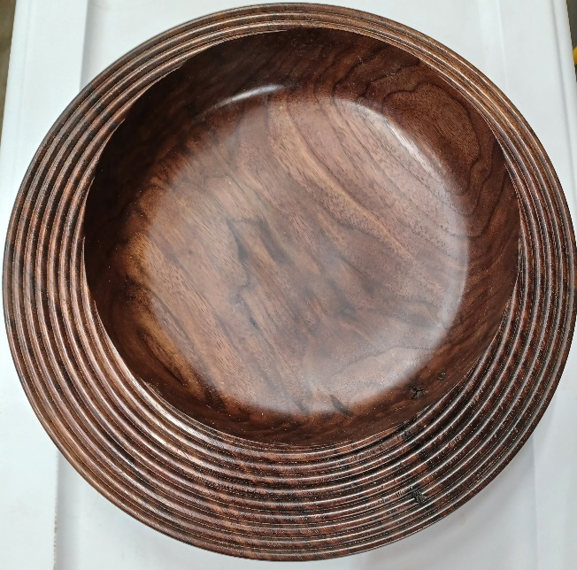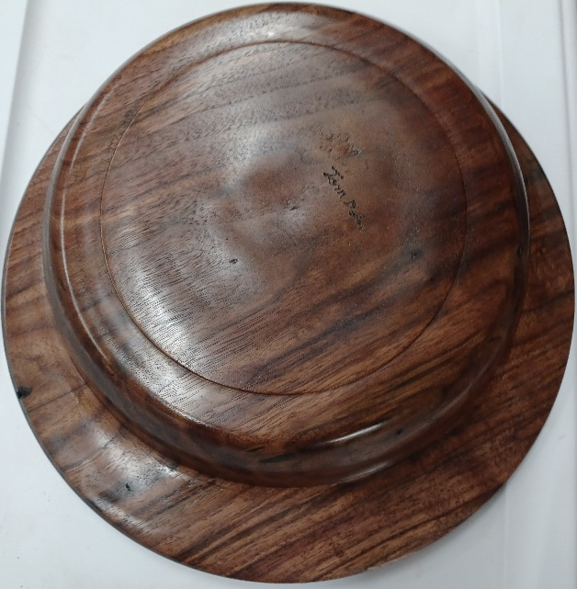
Blank 10 to 12” X 2.5 to 3” minimum thickness 2”, ruff cut round with band saw or chainsaw.
Layout bowl, decide size of offset bowl using compass or circle cutting guide to size offset portion mark second center.
Drill worm screw holes on top side of blank for both circles (my worm screw needs a 5/16” hole at least ¾” deep) if your blank is less than 2.5” be careful not to drill the offset hole too deep.
Mount on worm screw using the center hole lock spindle and make sure the blank is tight on screw use chuck with large jaws or add wood spacer to increase surface and for a more secure hold.
Turn round using tail stock support, flatten bottom, turn recess, turn bottom of wing to set thickness 3/8 to ½”. Start shaping the outside of bowl to reduce weight.
Reverse bowl into chuck and flatten top of blank and do edge treatment now, sand top now this is last chance to power sand.
Remount on Worm screw using off center hole, shape the sides making sure to have a rim all the way around the offset area, remove the old recess and flatten the bottom. Sand bottom of wing now.
Turn new recess and reverse into chuck, turn inside of bowl sand and finish.
Remove recess with jam chuck or vacuum chuck finish bottom.

